1. ER Diagram

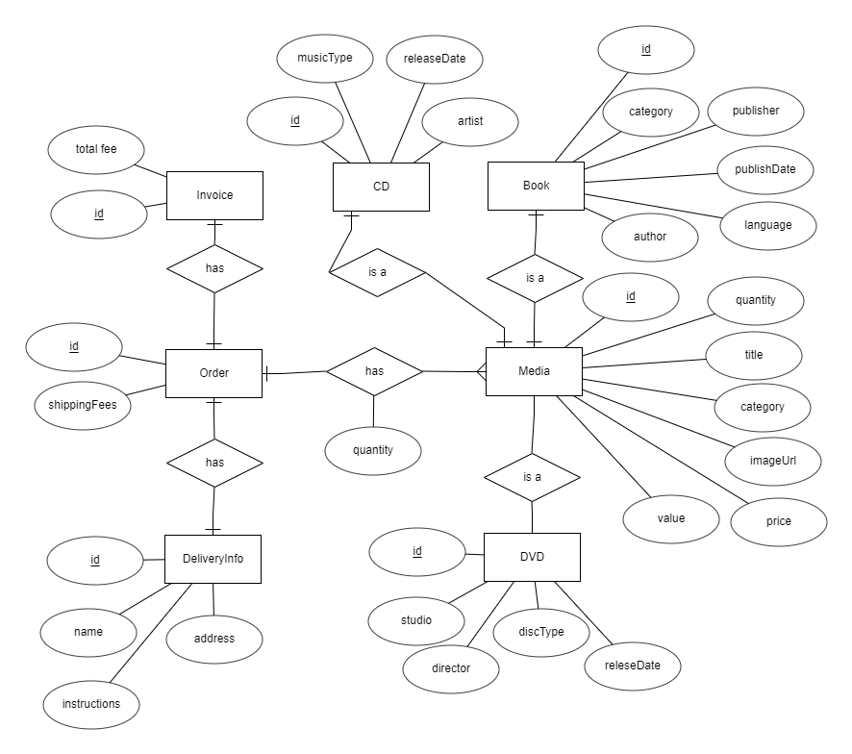

1. Logical Data Model

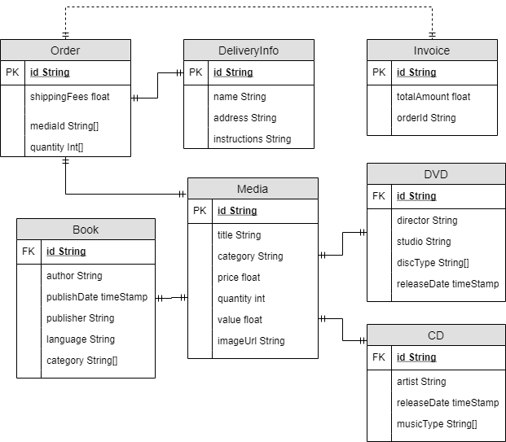

1. Physical Data Model ( NoSQL-MongoDB)

Use database

1. Order

|  |  |  |  |  |  |  |
| --- | --- | --- | --- | --- | --- | --- |
| # | PK | FK | Name | Data Type | Mandatory | Description |
| 1 | V |  | Id | String | Yes | // |
| 2 |  |  | shippingFee | float | Yes | // |
| 3 |  | v | deliveryInfo | String | yes | // |
| 4 |  | v | mediaId | String[] | yes | // |
| 5 |  |  | quantity | int | yes | // |

db.createCollection(order)

1. DeliveryInfo

|  |  |  |  |  |  |  |
| --- | --- | --- | --- | --- | --- | --- |
| # | PK | FK | Name | Data Type | Mandatory | Description |
| 1 | V |  | Id | String | Yes | // |
| 2 |  |  | name | String | yes | // |
| 3 |  |  | address | String | Yes | // |
| 4 |  |  | instructions | String | no | // |

db.createCollection(deliveryInfo)

1. Invoice

|  |  |  |  |  |  |  |
| --- | --- | --- | --- | --- | --- | --- |
| # | PK | FK | Name | Data Type | Mandatory | Description |
| 1 | V |  | Id | String | Yes | // |
| 2 |  |  | totalAmount | float | Yes | // |
| 3 |  | v | orderId | String | yes | // |

db.createCollection(invoice)

1. Media

|  |  |  |  |  |  |  |
| --- | --- | --- | --- | --- | --- | --- |
| # | PK | FK | Name | Data Type | Mandatory | Description |
| 1 | V |  | Id | String | Yes | // |
| 2 |  |  | title | String | Yes | // |
| 3 |  |  | category | String | yes | // |
| 4 |  |  | price | int | yes | // |
| 5 |  |  | quantity | int | yes | .. |
| 6 |  |  | value | float | yes |  |
| 7 |  |  | imageUrl | String | yes |  |

db.createCollection(media)

1. CD

|  |  |  |  |  |  |  |
| --- | --- | --- | --- | --- | --- | --- |
| # | PK | FK | Name | Data Type | Mandatory | Description |
| 1 |  | v | Id | String | Yes | // |
| 2 |  |  | artist | String | Yes | // |
| 3 |  |  | realeseDate | timeStamp | yes | // |
| 4 |  |  | musicType | String[] | yes | // |

db.createCollection(cd)

1. DVD

|  |  |  |  |  |  |  |
| --- | --- | --- | --- | --- | --- | --- |
| # | PK | FK | Name | Data Type | Mandatory | Description |
| 1 |  | v | Id | String | Yes | // |
| 2 |  |  | director | String | Yes | // |
| 3 |  |  | studio | String | yes | // |
| 4 |  |  | discType | String[] | yes | // |
| 5 |  |  | releaseDate | TimeStamp | yes | // |

db.createCollection(dvd)

1. Book

|  |  |  |  |  |  |  |
| --- | --- | --- | --- | --- | --- | --- |
| # | PK | FK | Name | Data Type | Mandatory | Description |
| 1 |  | v | Id | String | Yes | // |
| 2 |  |  | Author | String | Yes | // |
| 3 |  |  | Publisher | String | yes | // |
| 4 |  |  | Category | String[] | yes | // |
| 5 |  |  | publishDate | TimeStamp | yes | // |
| 6 |  |  | language | String | yes | // |

db.createCollection(book)